Phenix Payton
NET2300
Sanitizer Prep Report
3/24/26
1. Docker Compose environment up and running
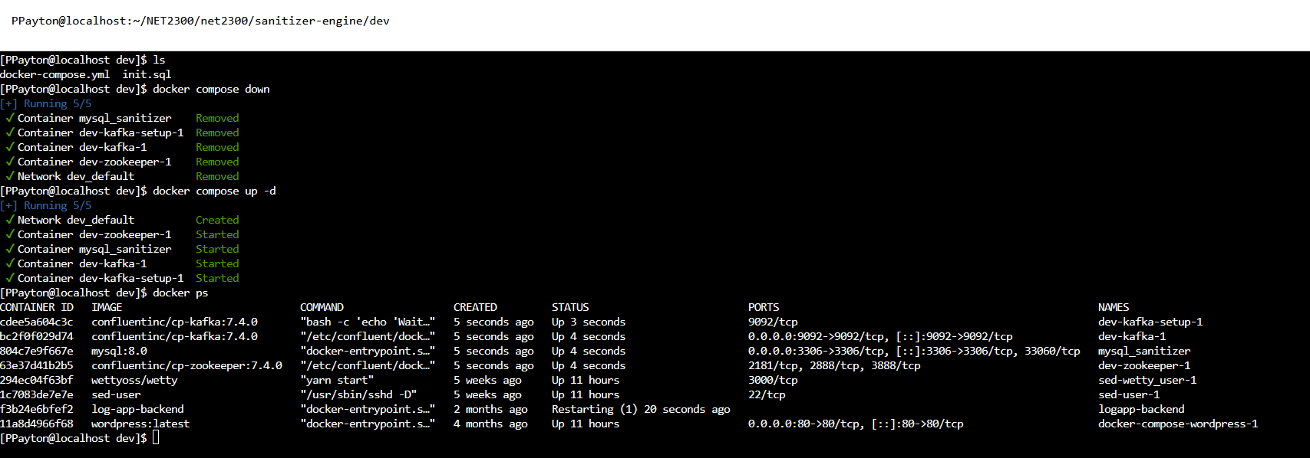
2. Insert, Read, and Update two tables (request and record) using scripts
Request table:
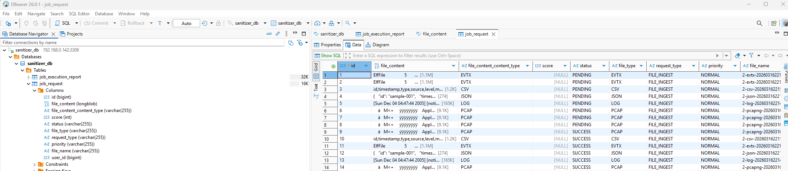
Report table:
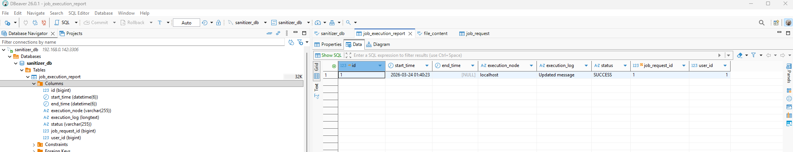

Scripts:
Ingress-db.sh:
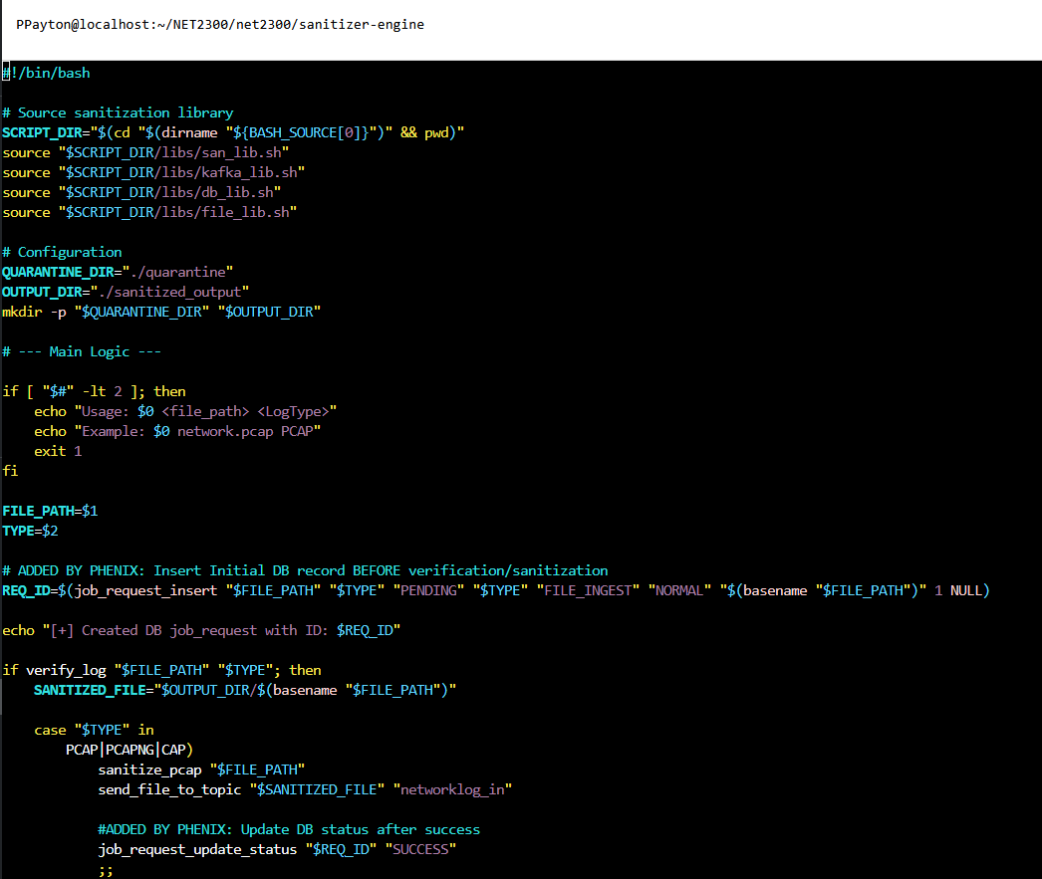
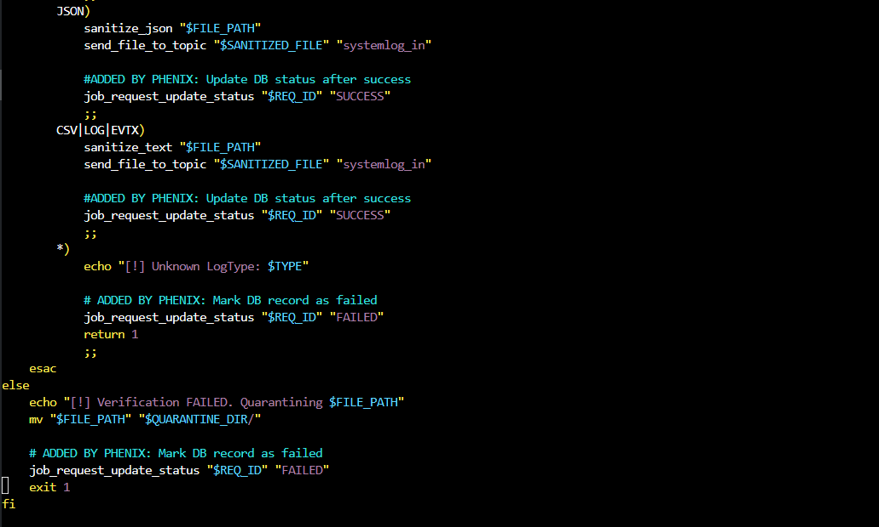
Insert_report.sh
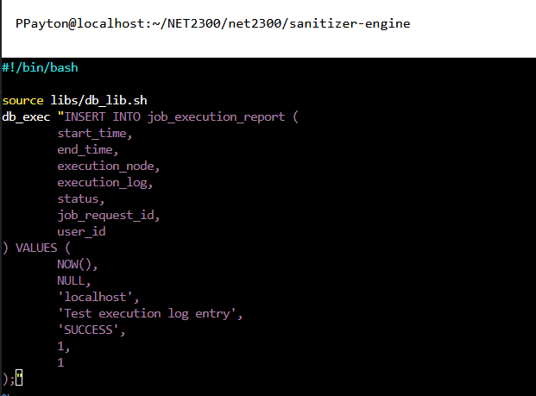
read_report.sh
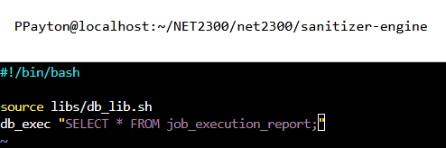
update_report.sh
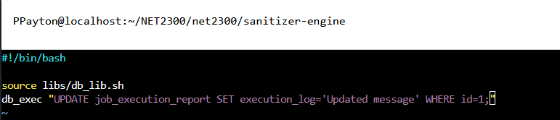

Script Runs:
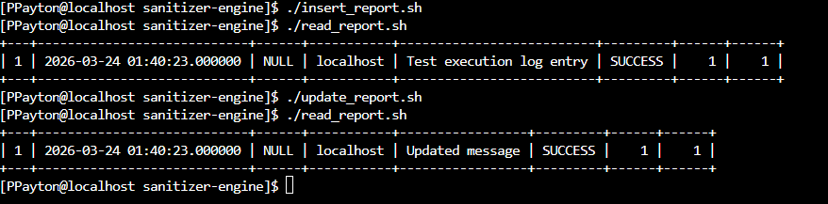
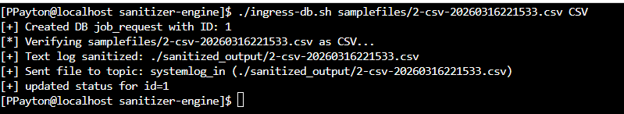
3. Send to and read from Kafka Topics using scripts
Send to systemlog_in topic (Done in ingress-db.sh script):

Send to networklog_in topic (Done in ingress-db.sh script):
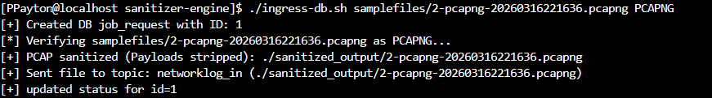
Read from systemlog_in topic (Done in consume_kafka_docker.sh):
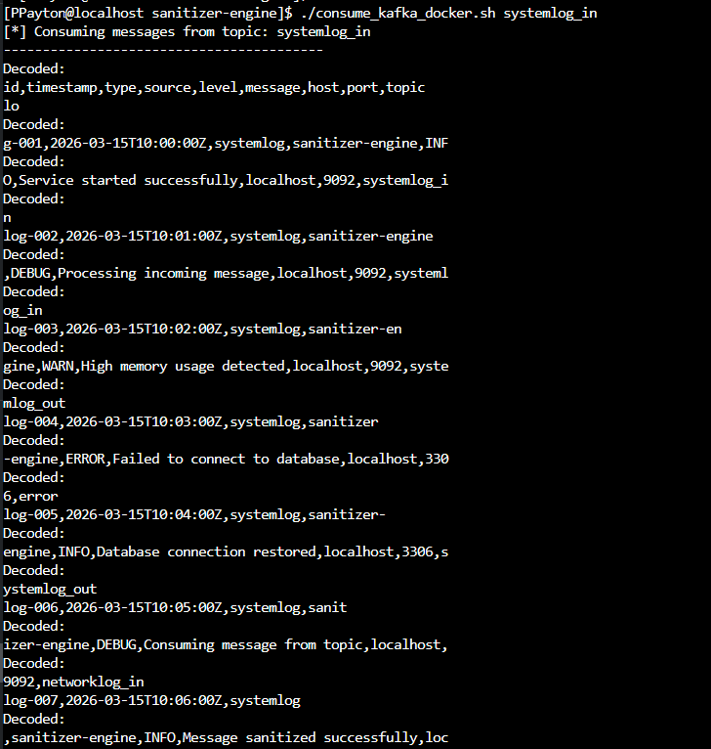
Read from networklog_in topic (Done in consume_kafka_docker.sh):
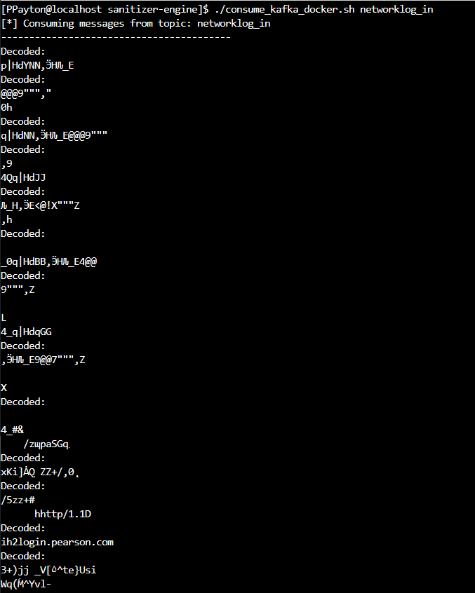
Consume_kafka_docker.sh script:
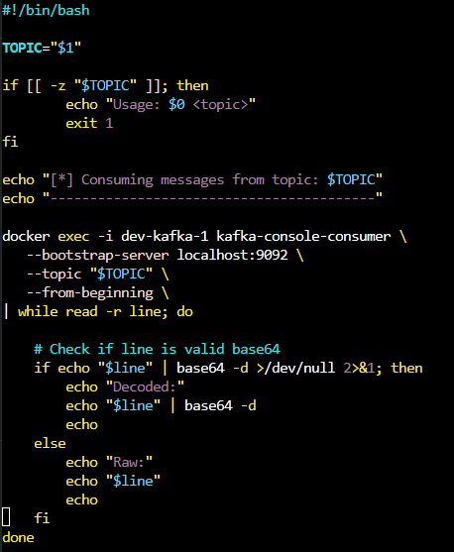
4. Research file types under sample files folder
CSV – Comma-Separated Values. A plaintext data format where each row is a record and each column is separated by a comma. Commonly used in system and audit logs and can be easily parsed or piped into SIEM systems, databases, etc.
JSON – JavaScript Object Notation. A structured, human-readable data format using key value pairs. Used for passing data from web servers to clients and can be used in SIEM scripts/applications.
EVTX – Windows Event Log Format. Windows proprietary binary data format used by Windows Event Viewer. Used for system, security, and application logs on Windows machines. Needs decoded to be human readable.
logtmp – Temporary Log Files. Not a standardized format but a temporary log file created by applications during logging, rotation, or buffering. Usually in plaintext.
PCAPNG – Packet Capture Next Generation. The modern packet capture format used by Wireshark, replacing the classic .pcap. Used to see all the traffic on a network and can be parsed/piped to SIEM systems.
5. Research on Kafka (three reasons why use Kafka, 50-100 words) to learn more:
Kafka is used in this log-sanitization system because it provides a fast, reliable way to move large amounts of data between systems. It can handle sudden bursts of many files, like multiple EVTX or PCAPNG logs, without slowing down the sanitizer or the database. Kafka also separates the sanitizer from downstream systems, ensuring logs are stored durably and can be reprocessed or consumed by analytic and AI tools.

GitHub Repo: https://github.com/PhenixP02/sanitizer-engine.git

